Name node

Name node acts as the center piece of all the other node. It is also called as master node. It consist of all the meta data and the directory tree of the file system and keeps tracks on accessing the nodes and data in hdfs. It does not contain any data. Namenode only knows list of blocks and location of any file in hdfs. If a name node fails wee cannot access the data nodes and data present in ddata nodes under the name node. It has more ram and it is single point of failure in hadoop distributed system.

Hdfs dfs –ls

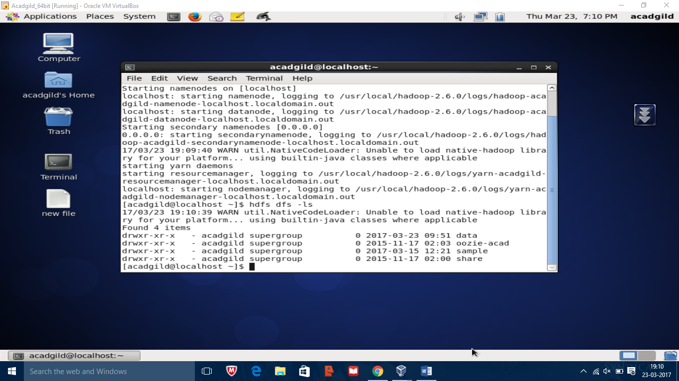

Hadoop –mkdir /assignment

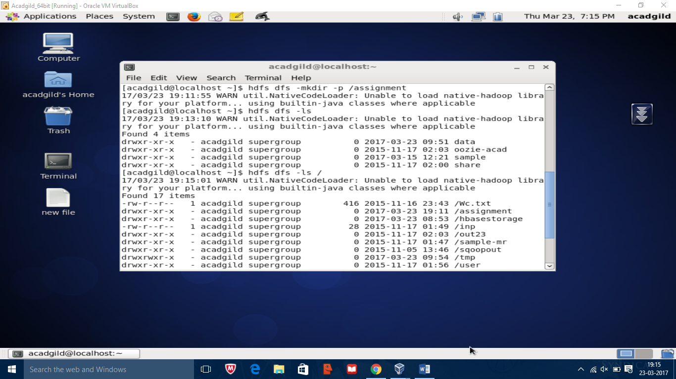

Hadoop fs –put /home/acadgild/Downloads/data/file.txt /assignment

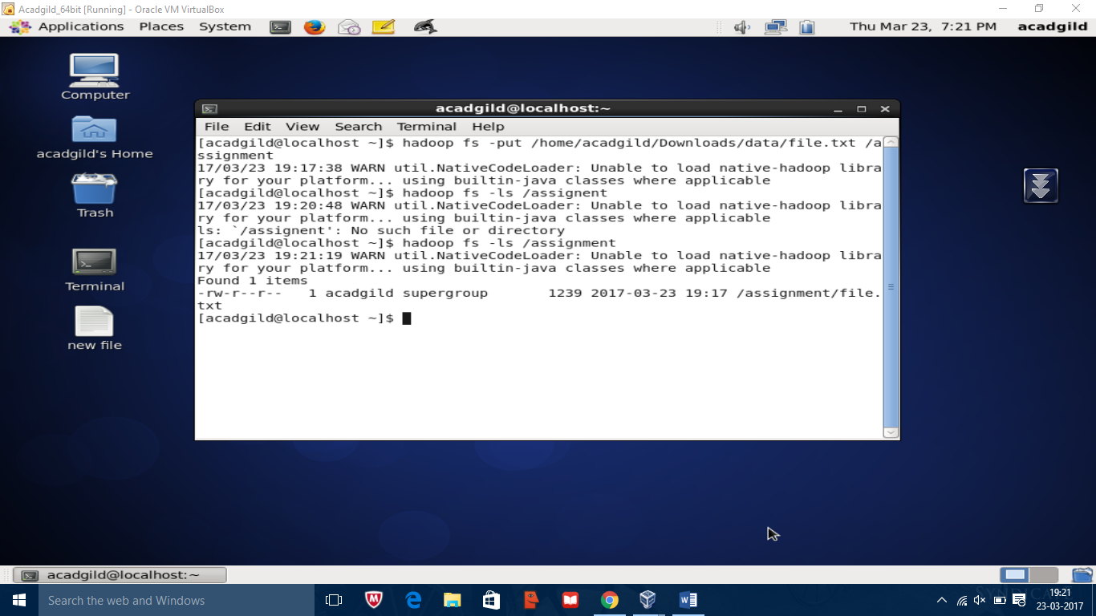

Hadoop fs –get /assignment /home/acadgild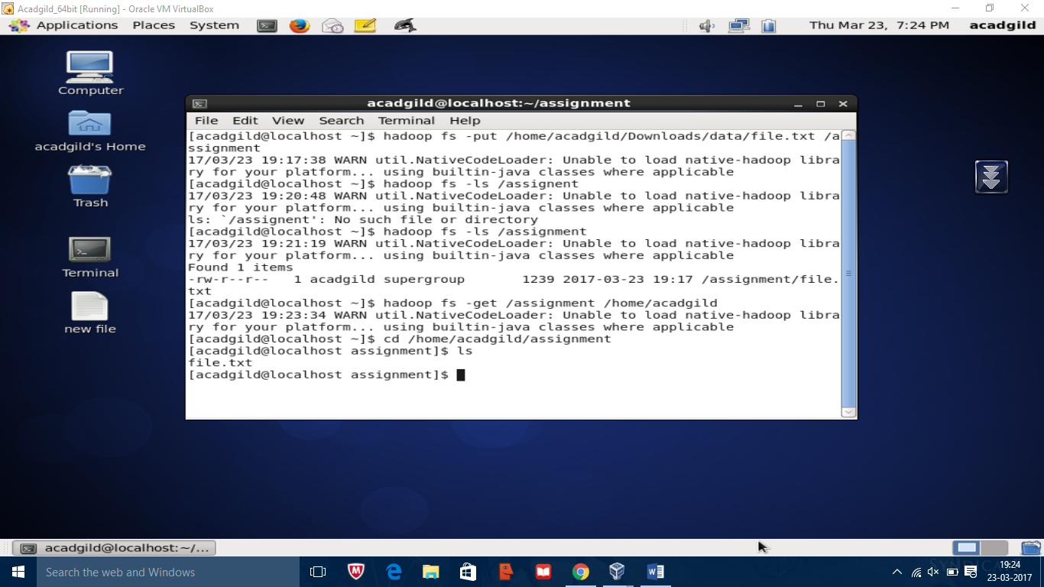

Hadoop fs –cat /assignment/file.txt

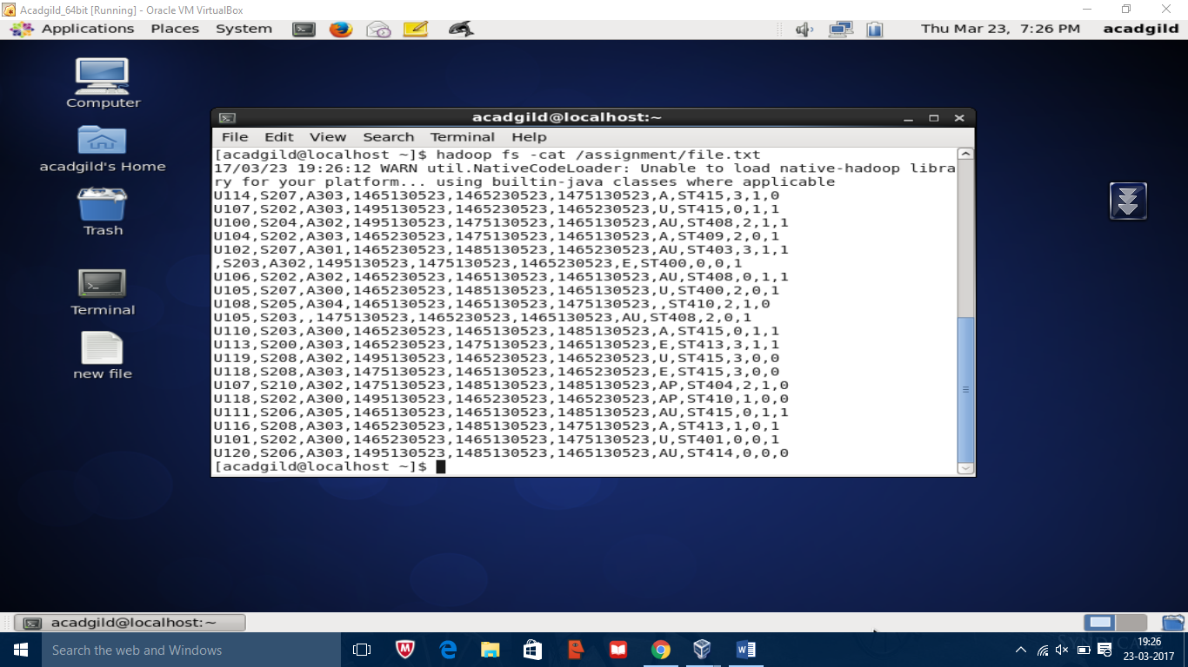

Hadoop fs –copyFromLocal

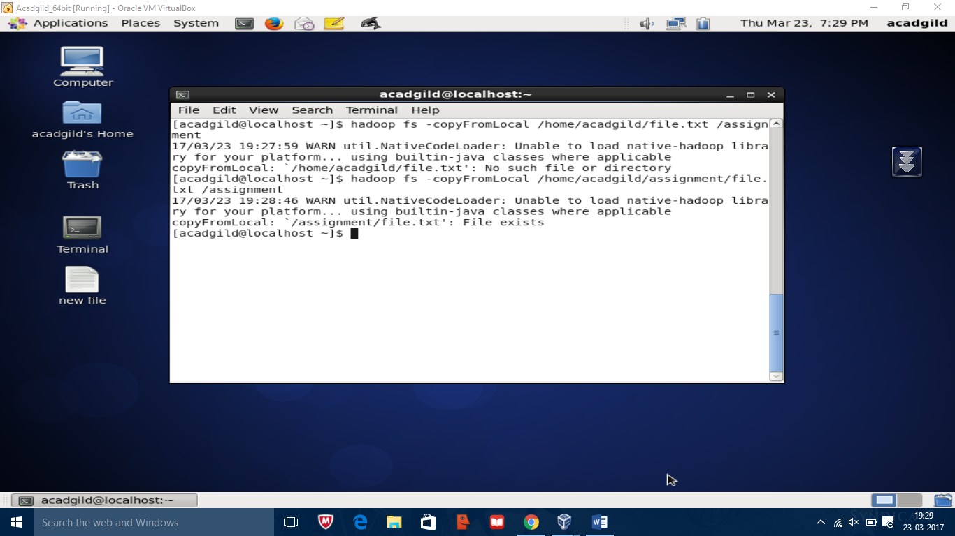

Hadoop fs –copyToLocal

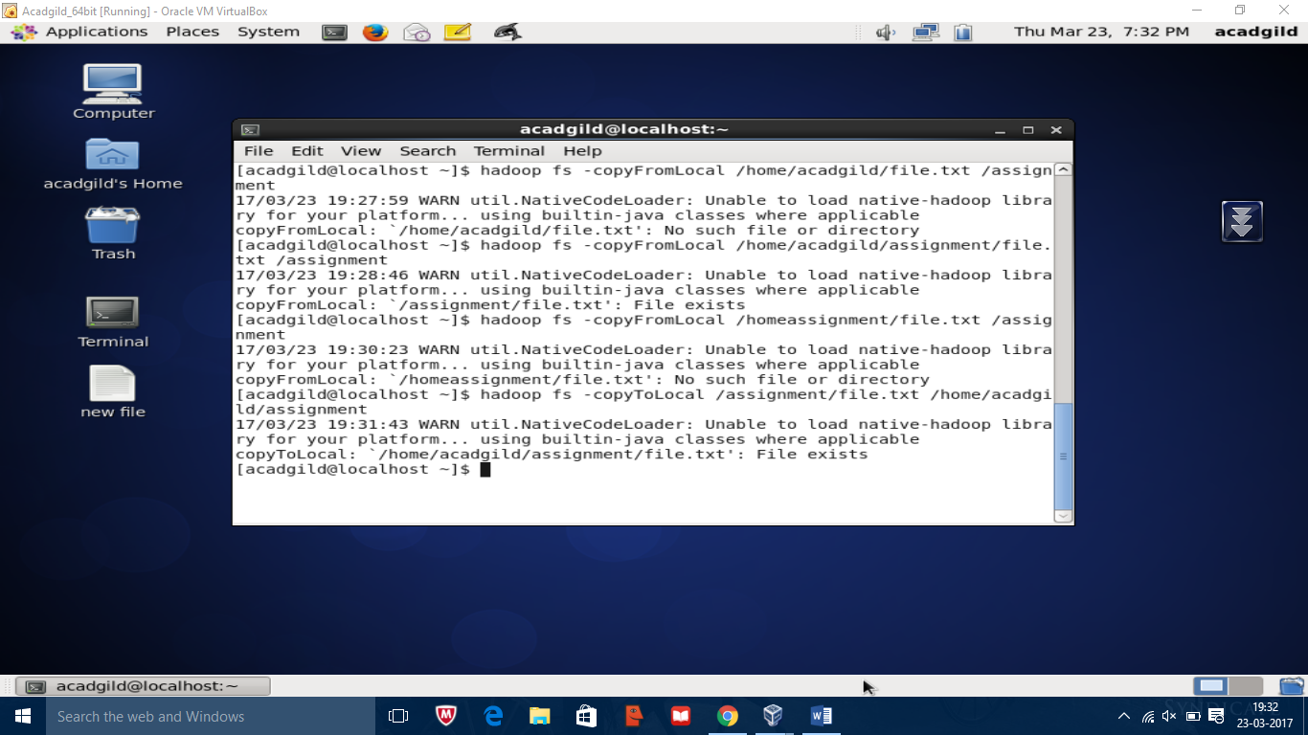

Hadoop fs –rm

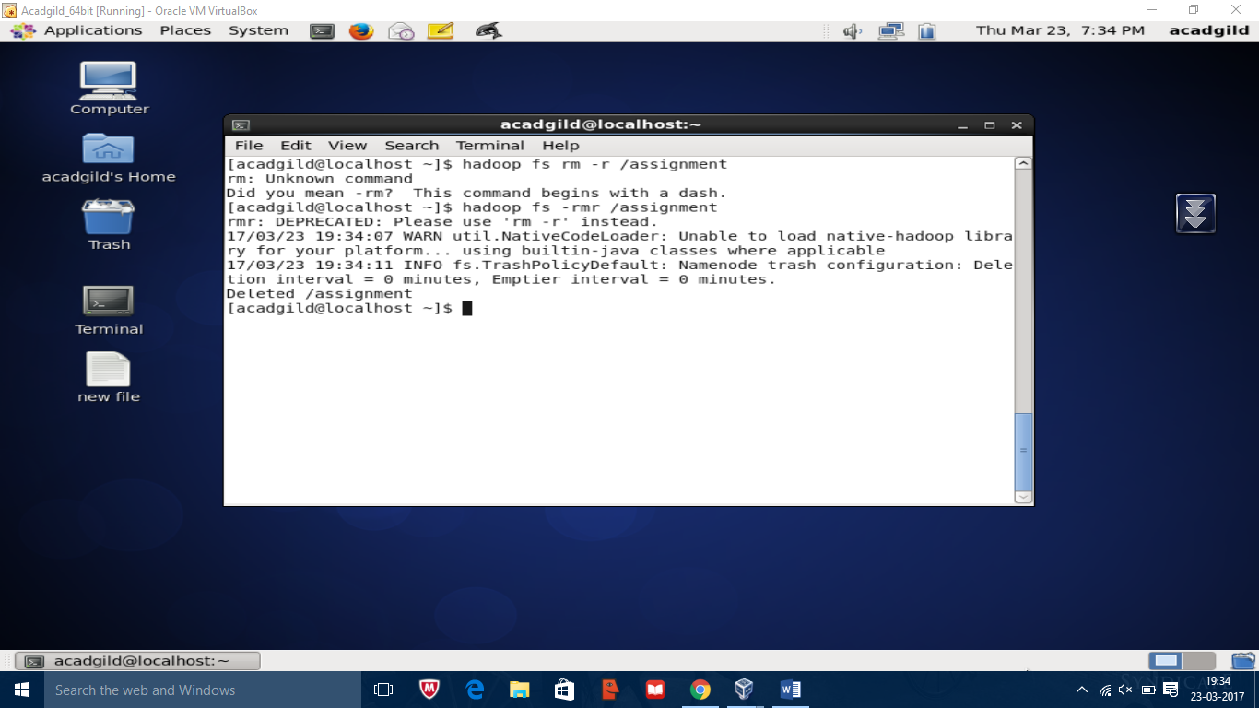

Hadoop fsck

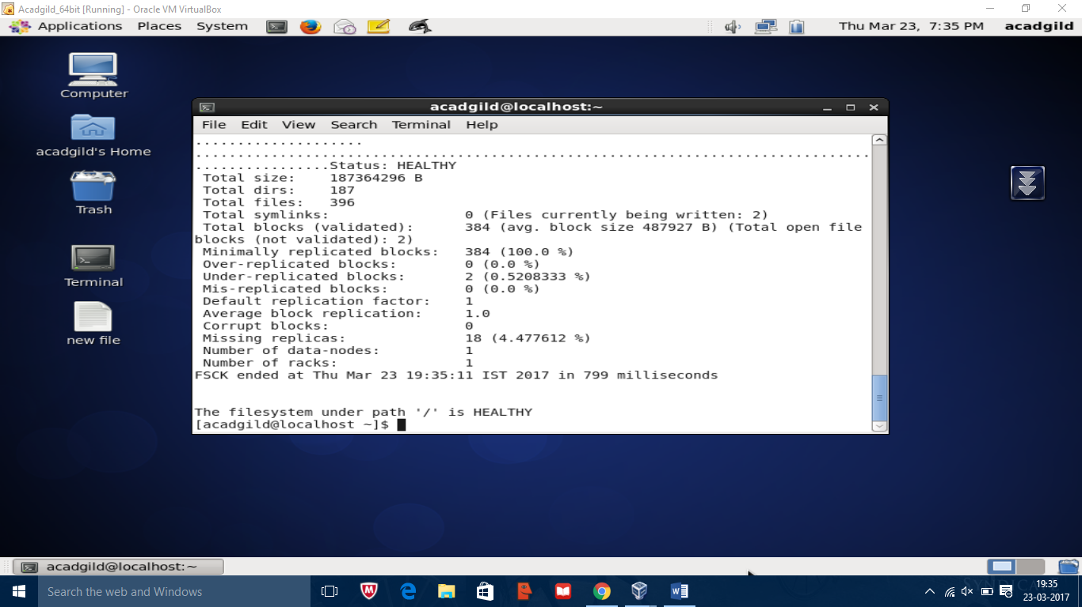

Hadoop balancer

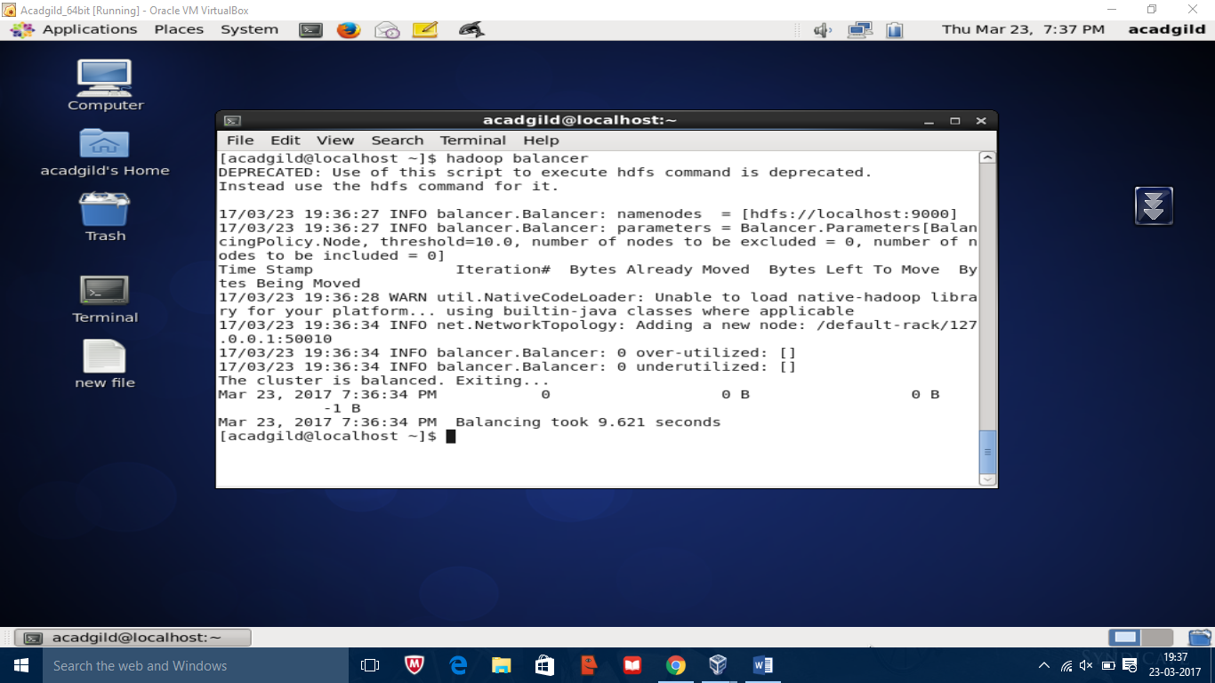

Hadoop fs

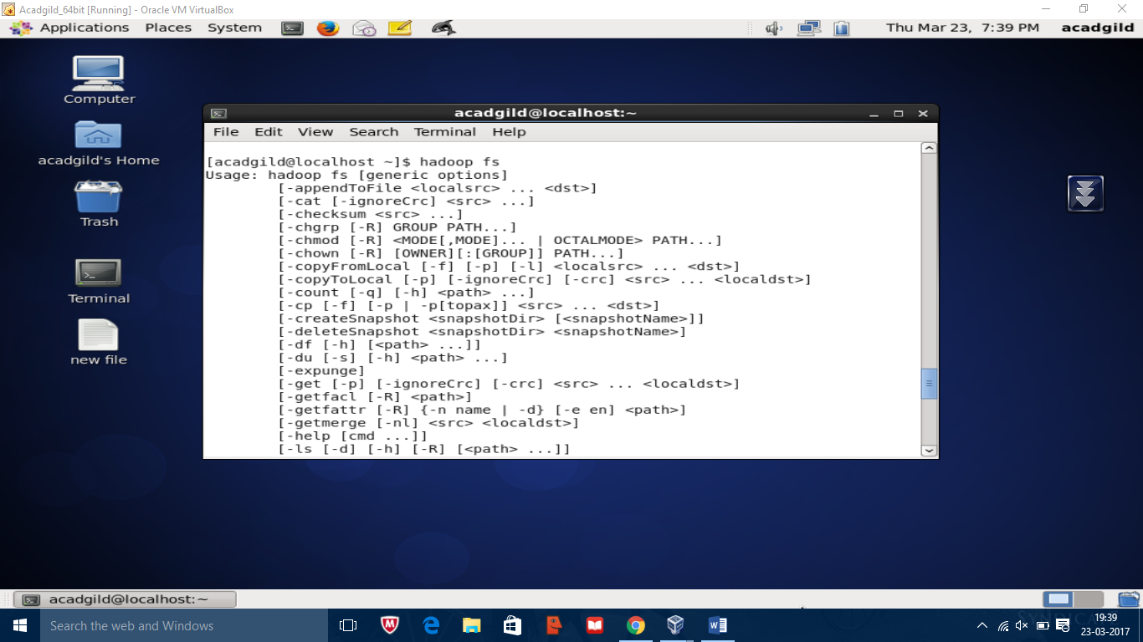

Hadoop fs -help

